Resources available for download from RACGP website

The National Guide is a practical resource intended for all health professionals delivering primary healthcare to Aboriginal and/or Torres Strait Islander people.
Its purpose is to provide GPs and other health professionals with an accessible, user-friendly guide to best practice preventive healthcare for Aboriginal and Torres Strait Islander patients.

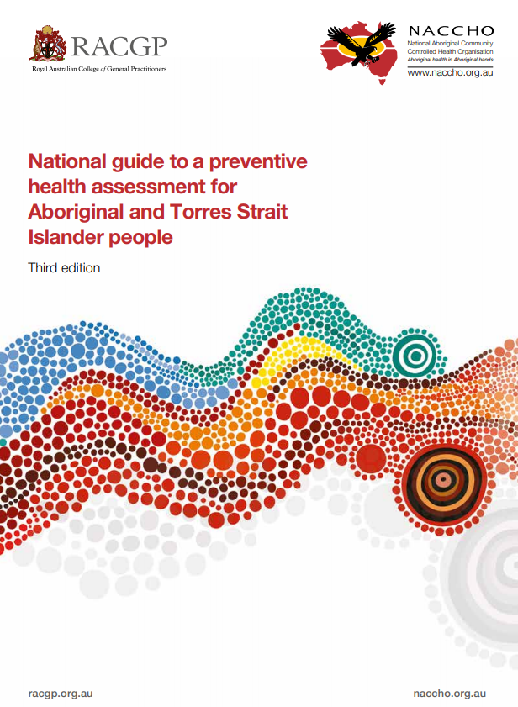 | 