Appendix 2 – Model For Improvement and PDSA Template

1.0 Model for Improvement and Plan-Do-Study-Act Cycle
Start by documenting your practice QI team and define your problem and specified a robust Problem Statement using the Quality Improvement Template. Next, consider Model for Improvement.
In the Model for Improvement, the 'Thinking Part' focuses on the overall improvement strategy, while the 'Doing Part' implements changes through the Plan-Do-Study-Act (PDSA) cycle. This model uses PDSA cycles to test changes, ensuring measurable and sustainable improvements.
Click here for a short video explaining the Model for Improvement and PDSA’s.
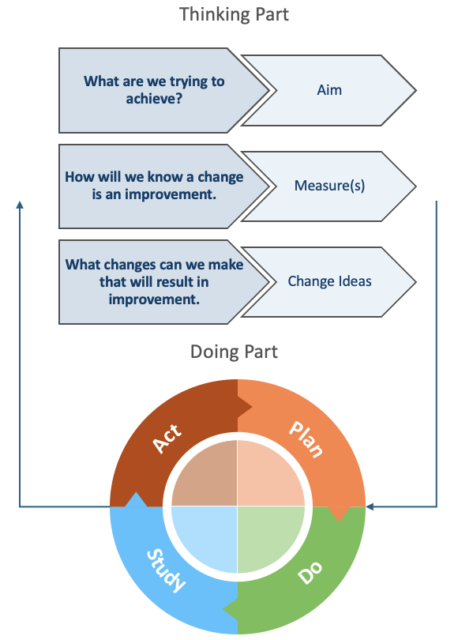
Step 1: Thinking Part - Model for Improvement
- AIM: What are we trying to accomplish? Develop a S.M.A.R.T. (Specific, Measurable, Attainable, Realistic, Time-bound) and people-crafted Aim Statement.
- MEASURE: How will we know that a change is an improvement? Identify what good looks like and develop a measure(s) of success.
- CHANGE IDEAS: What changes can we make that will result in an improvement? Engage the whole team in formulating change ideas using tools such as brainstorming, driver diagrams or process mapping. Each change idea may involve multiple small rapid PDSA cycles.
Step 2: Doing Part - Plan-Do-Study-Act (PDSA)
- PLAN: Describe the change idea (what, who, when, where). Predict outcomes and define the data to collect.
- DO: Carry out the plan. Collect data. Consider what worked well and why? Document any unexpected observations, events or problems.
- STUDY: Analyse results, compare them to predictions, and reflect on what you learned.
- ACT: Based on what you learned from the test, consider what you will do next (e.g., adopt, adapt or abandon)? How does this inform the plan for your next PDSA?
Source: Langley, G., Nolan, K., Nolan, T., Norman, C. & Provost, L. 1996, The Improvement Guide, Jossey-Bass, San Francisco, USA

1.1 Quality Improvement Template

Practice name: | Add your primary healthcare service name here | Date: | Add date of commencement here
QI team: | List the team members involved
Problem: | Describe why this work is strategically important. What problem is the team addressing? What does our data indicate about it, and what are the causes?
Problem Statement: | Document your succinct problem statement here
Once you have completed the QI template, move onto the Model for Improvement (the Thinking Part)
For guidance and support on conducting quality improvement in your primary healthcare services, please contact your local Primary Health Network (PHN).

