
4.2.3 Explore Chronic Conditions Management changes with your practice team
A summary of CCM changes can be found in Section 3 of this workbook.

Have a team discussion and pose some open questions such as:

- How are these changes similar or different to current CDM care?

- Are our practice nurses or Aboriginal and Torres Strait Islander health practitioners confident in management planning or is there more training or development to enhance their skills and roles?

- What is our ratio of management plans to management plan reviews at the moment? What changes would we need to make to enable reviews to be scheduled as clinically appropriate?

- More considerations for planning are included in the CCM Checklist.

More information is available at these links

- MBS Online

Plan Do Study Act
The following example MFI and PDSA is relevant to this section and these activities.

These are also located in the Appendix section of this document – Appendices.
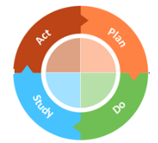
3.5 MFI and PDSA – Team awareness, desire and readiness

