4.4 Recall existing CCM patients

Vaccine reminders
RACGP standards require preventive care and tailored reminders, including for patients with limited English.
Use your software to identify and remind patients due for vaccines.
Software | Adding reminders | Create mail merges | Create bulk SMS | Adding notes
Best Practice | Add a Clinical Reminder to a patient | Send Health Awareness Communications | Send clinical reminders | Add and review contact notes
Medical Director | Recall, Reminders, Actions and Outstanding Requests | Mail merge | Sending SMS reminders | Editing a patient’s details from within their record

Plan Do Study Act
The following example MFI and PDSAs are relevant to this section and these activities.
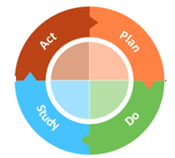
These are also located in the Appendix section of this document – Appendices.
3.9 MFI and PDSA – Patient Engagement and Reminders
3.10 MFI and PDSA - Reducing Missed Appointments

