
Section 1 - MyMedicare and Chronic Conditions Management Foundations
Section Navigation
  - MyMedicare and MyMedicare Registration
  - Person centred care
  - Chronic Conditions Management (CCM)


This section introduces the MyMedicare initiative, person-centred care principles, and the Chronic Condition Management (CCM) framework. It also highlights the roles and responsibilities of healthcare providers, practices, and multidisciplinary teams in delivering CCM.
Links to practical resources and activities are included to support implementation.

1.1 MyMedicare and MyMedicare registration

MyMedicare is a voluntary patient registration (VPR) model that aims to strengthen the relationship between patients, their preferred general practice, GP, and primary care team. More detailed information about MyMedicare, what it is, benefits, eligibility requirements and how to participate are available here.
MyMedicare creates an identifiable bond in the digital health ecosystem between one general practice and a patient, that aims to enhance continuity of care and reduce fragmentation. MyMedicare registration is also a requirement for general practices' to claim some MBS Items or participate in a number of incentives.
General practices can register via the Organisation Register while patients can register through the myGov Mobile app, Medicare Online or by completing a paper registration form. Registration with MyMedicare is voluntary for patients, practices, and providers.


Patient
- By choosing their MyMedicare general practice, a patient is deciding which general practice can access CCM MBS Items to manage their long-term health conditions.
- MyMedicare Patient Registration here Information for MyMedicare patients | Australian Government Department of Health, Disability and Ageing
Practice
- By registering for MyMedicare, a practice and patient are making a commitment to working together into the future as the patient’s health and life needs change.
- MyMedicare Practice Registration resources here: MYMEDINFO1-Checklist and steps to register for MyMedicare on the Organisation Register
Practice
- By registering for MyMedicare, a practice and patient are making a commitment to working together into the future as the patient’s health and life needs change.
- MyMedicare Practice Registration resources here: MYMEDINFO1-Checklist and steps to register for MyMedicare on the Organisation Register

1.2 Person Centred Care
Person-centred care is the foundation of both Chronic Condition Management (CCM) and MyMedicare.
‘Healthcare that respects the individual, their family, and carers, and responds to their preferences, needs, and values’ which leads to improved health outcomes. (The Australian Commission on Safety and Quality in Healthcare)

The CCM framework aims to support general practices to develop proactive management plans tailored to each patient’s unique needs, preferences, and goals. MyMedicare creates a unique and identifiable link between a patient and a general practice to improve continuity of care. By putting patients at the centre, both initiatives aim to strengthen engagement, to achieve better health outcomes.
The four core principles of person-centred care include:
- treating individuals with dignity, compassion, and respect.
- providing coordinated care, support, and treatment.
- offering personalised care tailored to individual needs; and
- empowering people to recognise and build on their strengths to lead more independent and fulfilling lives.

Person-centred care begins by asking your patients "What matters to you?" rather than "What’s the matter with you?" This approach builds a stronger understanding between patients and providers, connecting patients’ life goals with their health goals. It fosters greater patient engagement in the management planning process and supports tailored, meaningful care.

1.3 Chronic Condition Management (CCM)
Why it is important
Australia is facing a rising burden of chronic disease, alongside growing patient expectations and evolving digital tools that support connected, multidisciplinary care. Among people of all ages, an estimated 15.4 million (61%) were living with at least one long-term health condition in 2022. This ranged from 28% of people aged 0–14 to 94% of people aged 85 and over (AIHW). Living with chronic conditions can have a substantial impact on an individual’s health and requires considerable investment in Australia’s health system.
The terms chronic disease, preventable chronic diseases, chronic conditions, long term disease/conditions are commonly used interchangeably. In this workbook, the term ‘chronic conditions’ is used as an overarching term.

Chronic conditions are expected to persist and impact a person’s health for a longer period. Some Chronic Conditions can have a shorter duration, whilst others can persist for the remainder of a person’s life. Chronic conditions are strongly influenced by the social determinants of health.
Many Chronic Conditions respond well to treatments and interventions which can prevent health decline or reduce impacts on a person’s life. Continuity of care and reviews of chronic condition management plans are necessary to:
- support the patient to understand and self-manage their chronic condition,
- coordinate care and referrals with a patient’s multidisciplinary team
- monitor symptoms and health,
- review and update medications,
- plan, conduct and review tests and screening
- update plans in response to changing patient needs, treatment options and evidence.
The infographic below depicts an example of management planning for a chronic condition patient. Review appointments as clinically relevant support ongoing patient engagement and care continuity.
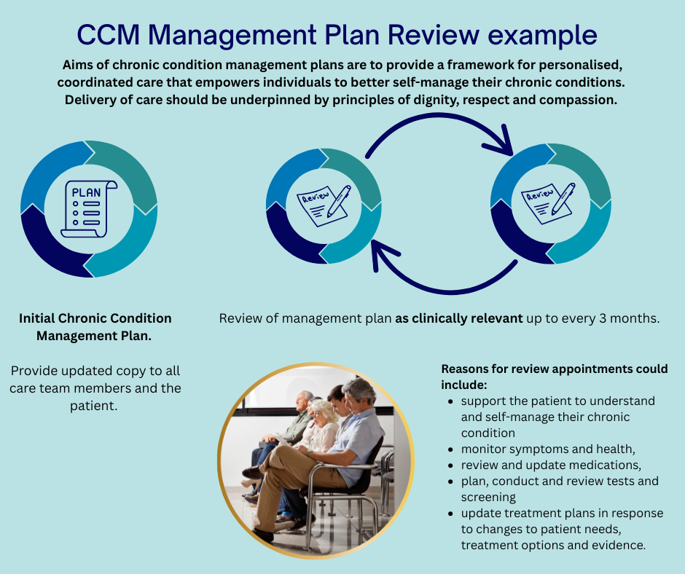
For patients diagnosed with a chronic condition that is expected to impact their health for longer than 6 months (or is terminal), Chronic Conditions MBS items support general practices to develop plans and continue to actively manage, monitor, and coordinate ongoing care. CCM items also support access and referral to allied health and other services for patients, including those that would benefit from multidisciplinary team care to manage their chronic condition. Patients can track their care plan items via their Medicare Online Account – Chronic Condition Management Tracker.

1.4 Relevant resources – See Section 5

