

Section 3 - Delivering care to meet CCM MBS requirements
Section Navigation
3.1 Chronic Conditions Management (CCM) MBS changes and information
3.2 Referral Pathways for Allied Health Services
3.3 CCM MBS User Guide
3.4 Patient Drivers for Attending Chronic Condition Review Appointments



Chronic Conditions Management MBS Items include initial Chronic Condition Management plans and reviews of a chronic conditions management plan. Patients registered with MyMedicare can only access Chronic Condition Management (CCM) plans and reviews through their MyMedicare general practice. Patients not enrolled in MyMedicare can access CCM services from their usual GP.

For the full details see MBS Online.

3.1 Chronic Conditions Management (CCM) MBS changes and information
Changes to Chronic Disease Management and MBS items
Chronic Conditions Management (CCM) MBS item changes recommended by the MBS Review Taskforce simplify, streamline, and modernise the arrangements for health care professionals and patients.
Transition arrangements will be in place for 2 years to ensure current patients do not lose access to services.
From 1 July 2025:
Items for GP management plans (229, 721, 92024, 92055), team care arrangements (230, 723, 92025, 92056) and reviews (233, 732, 92028, 92059) will cease and be replaced with new streamlined GP chronic condition management items (see table below for item numbers).
To support continuity of care, patients registered through MyMedicare will be required to access the GP chronic condition management plan and review items through the practice where they are registered. Other patients will be able to access the items through their usual GP.
Where multidisciplinary care is required, patients will be able to access the same range of services currently available through GP management plans and team care arrangements.
GPs and prescribed medical practitioners will refer patients with a GP chronic condition management plan to allied health services directly. The requirement to consult with at least two collaborating providers, as described under the current team care arrangements will not apply.
Practice nurses, Aboriginal and Torres Strait Islander health practitioners and Aboriginal health workers will be able to assist the GP or prescribed medical practitioner to prepare or review a GP chronic condition management plan.
To support reviews and ongoing care as clinically appropriate, the MBS fees for planning and review items have been equalised. The fee for the preparation or review of a plan in $156.55 for GPs and $125.30 for prescribed medical practitioners (current as of 1 July 2025). Patients will also need to have their GP chronic condition management plan prepared or reviewed in the previous 18 months to continue to access allied health services.
Consistent with current arrangements, unless exceptional circumstances apply, a GP chronic condition management plan can be prepared once every 12 months (if necessary), and reviews can be conducted as clinically appropriate but not more frequently than once every 3 months. It is not required that a new plan be prepared each year; existing plans can continue to be reviewed.
Patients that had a GP management plan and/or team care arrangement in place prior to 1 July 2025 will be able to continue to access services consistent with those plans for two years. From 1 July 2027, a GP chronic condition management plan will be required for ongoing access to allied health services.
These changes do not affect MBS items (231, 232, 729, 731, 92026, 92027, 92057, 92058).
Table 1: Chronic Condition Management Items commencing 1 July 2025
Name of Item | GP item number | Prescribed medical practitioner item number
Prepare a GP chronic condition management plan – face to face | 965 | 392
Prepare a GP chronic condition management plan - video | 92029 | 92060
Review a GP chronic condition management plan – face to face | 967 | 393
Review a GP chronic condition management plan – video | 92030 | 92061

The figure below demonstrates how planned care and appropriate periodic reviews for patients with one or more chronic conditions contribute to the delivery of more person-centred care.

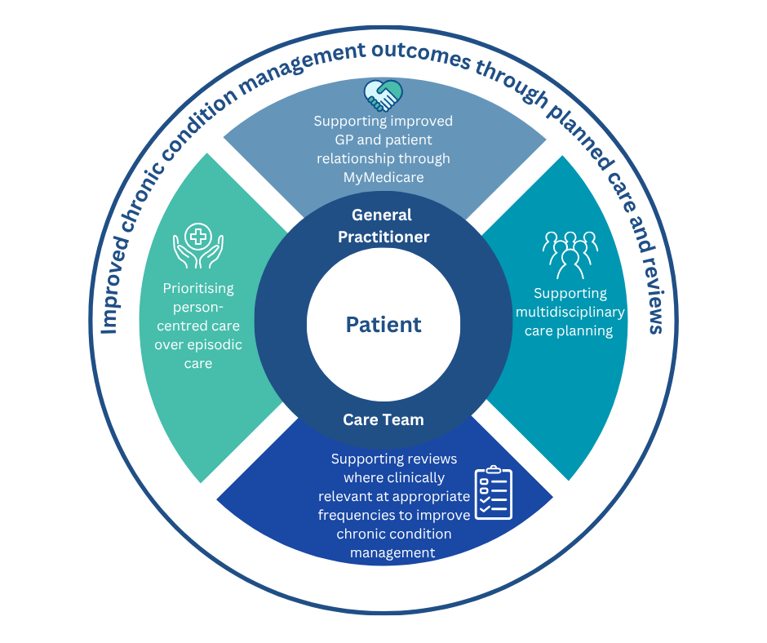

3.2 Referral Arrangements for Allied Health Services (For Chronic Condition Management)
As per MBS Online from 22 May 2025, referral requirements for most MBS-supported allied health services related to CCM on or after 1 July 2025, have been simplified to be more consistent with the arrangements for referrals to medical specialists.
- Any referrals for allied health services written prior to 1 July 2025 will remain valid until all services under the referral have been provided (see separate factsheet on transition arrangements).
- From 1 July 2025, Team Care Arrangement referral forms will no longer be used for referrals to allied health services
- There is no requirement for allied health providers to confirm acceptance of the referral or otherwise provide input into the preparation of the GP chronic condition management plan (GPCCMP).
- Requirements for allied health providers to provide a written report back to the GP after the provision of certain services (e.g. the first service under a referral) are unchanged.
- Unless otherwise specified by the referring medical practitioner, referrals to allied health services for patients with a chronic condition will be valid for 18 months.
- The new referral requirements apply to all allied health referrals under the chronic conditions management framework, as well as some other MBS-supported allied health services.
What are the changes?
From 1 July 2025, these requirements for referrals also apply to the following allied health services (and their video and phone equivalent) items:
- Group M3 (subgroup 1) – individual allied health services for patients with a chronic condition (referred under the chronic conditions management arrangements)
- Group M8 – pregnancy support counselling allied health services
- Group M9 – allied health group services for patients with type 2 diabetes (referred under the chronic conditions management arrangements)
- Group M10 (subgroup 1) – complex neurodevelopmental disorders and eligible disabilities allied health services
- Group M11 – allied health services for Aboriginal and Torres Strait Islander people (referred under the chronic conditions management arrangements or following a health assessment).
More information: MBS Online - Upcoming changes to the MBS Chronic Disease Management Framework

3.3 CCM MBS User Guide
Refer to the Chronic Conditions Management MBS User Guide for examples of how CCM management planning items can be used and claimed by general practices.
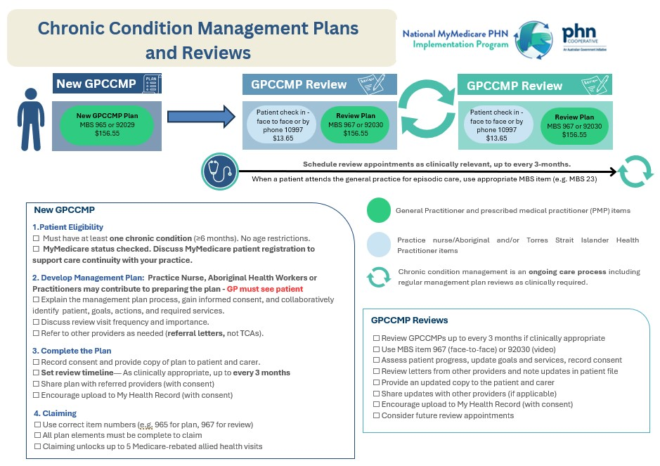

3.4 Patient Drivers for Attending Chronic Condition Review Appointments
Applying patient-centred care approaches contributes to better engagement in ongoing care with your practice team. Many Chronic Conditions require periodic review appointments for planned care, and patients need to feel a strong sense of engagement and see the value in attending appointments when they may otherwise feel quite well! The following patient review appointment engagement tips can help to increase attendance and engagement with patients at planned review appointments.

