


QuIK Cycle Year Cycle no. Number

Practice Name | QI Officer

Practice Contact

PDSA  Quality  Improvement  Activity Details | Activity Title
PDSA  Quality  Improvement  Activity Details | Cycle Dates
PDSA  Quality  Improvement  Activity Details | Cycle Length
PDSA  Quality  Improvement  Activity Details | QI Lead
PDSA  Quality  Improvement  Activity Details | GP Lead
PDSA  Quality  Improvement  Activity Details | Team

Data Trends | Baseline | Follow-up 1 | Follow-up 2 | Final
Dates

Quality Improvement and the QuIK Cycle
Capital Health Network uses the Model for Improvement and Plan-Do-Study-Act (PDSA) to guide the QuIK Cycle process.
Asking these questions helps develop relevant goals, tracking measures and ideas for change prior to commencing the QuIK Cycle:
Model for Improvement and PDSA (Image adapted)
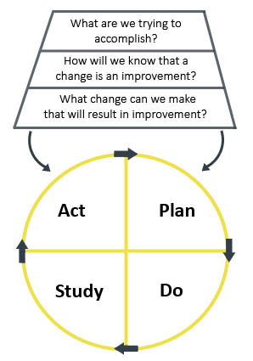

Goal
What are we trying to accomplish?
Measures
How will we know that a change is an improvement?
Ideas
What change can we make that will result in improvement?

PLAN
Capital Health Network’s (CHN) Quality Improvement Team is excited to be working with you and your practice to develop Plan, Do, Study, Act (PDSA) activities. Our goal is to assist you in developing comprehensive PDSA Activity Reports that can be used towards the practice’s RACGP accreditation for quality improvement. Your health professionals’ involvement in QuIK Cycles will also contribute to their personal CPD goals and requirements. If your practice shares data with us, we will also utilise the data available on POLAR to inform, measure, and evaluate the performance of each cycle.

Context
What is the topic or change idea?
What do you predict will happen?

Action Step 1
What exactly will be done?
Data measure to indicate change?

Tasks | Responsibility | Due date | Location | How?

Action Step 2
What exactly will be done?
Data measure to indicate change?

Tasks | Responsibility | Due date | Location | How?

Action Step 3
What exactly will be done?
Data measure to indicate change?

Tasks | Responsibility | Due date | Location | How?

Action Step 4
What exactly will be done?
Data measure to indicate change?

Tasks | Responsibility | Due date | Location | How?

DO
  - Your QI Project Officer will assist in monitoring the progress and performance of your PDSA activity. They will be in contact with you, or the delegate for this activity, every month at a mutually agreed time. This meeting can be done through an in-person or phone appointment. Your QI Project Officer will record the observations you’ve made since the last meeting and collect another set of data measures from the actions to measure any changes in data. The updated copy of your PDSA Activity will be available from any of our QI Project Officers.

Progress Monitoring
Record any observations around the activity so far.

Record any changes to the data specified in the actions.

STUDY
  - Your QI Project Officer will assist you in analysing the data trends spanning across the length of this Quality Improvement Activity. This analysis includes recording explanatory and context notes for why the data resulted in a certain way, your reflections when comparing the results with the activity aim, and the lessons learned from undertaking the Quality Improvement Activity. The updated copy of your PDSA Activity will be available from any of our QI Project Officers.

Analysis
Analyse data results.

Compare results with the activity aim.

Summary and reflection on what was learned.

ACT
  - Your QI Project Officer will record the actions which resulted from the Quality Improvement Activity. This will include details on what your practice will be adopting, rejecting, or modifying from the original plan to position your practice in the best possible way for a follow-up Quality Improvement Activity cycle. If the practice would like to immediately start a follow-up Quality Improvement Activity, your QI Project Officer will work with you to redefine the Context and start a new cycle which includes the results from the previous cycle.

Results
Act on the results.

Adopt, reject, or modify original plan as required.

Plan the next cycle (where applicable).

